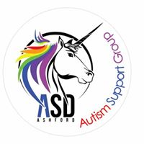
123 County Square Shopping, Elwick Road, Ashford, Kent. TN23 1AE

Autism Awareness Training Day
Friday 19th October
or
Friday 23rd November
​
9.30am till 5pm
Kennington Cricket Club
Ulley Rd,
Kennington,
Ashford
TN24 9HY
Cost for Parents/Carers £20 pp
Cost for Professionals £40 pp
This is a full day session and covers all the basics but in a way that leaves parents/professionals able to us the knowledge gained to better understand 'Autism' and put in place strategies. Topics included are 'What Autism actually is', 'The Autistic Spectrum Explained', 'Quick intro to Sensory issues', 'Challenging behaviour' and 'Changing the way WE think'.
Lunch isn't provided, so please feel free to bring something with you, Tea and Coffee is provided through the day.
​To book at place and check availability please email asdashfordgroup@gmail.com
Places are limited and payment is need at the time of booking to confirm your place, payment is non-refundable unless cancelled by us.
Payment can be made by paypal to asdashfordgroup@gmail.com or by cheque to our office; ASD ASHFORD
123 County Square Shopping Centre, Elwick Road, Ashford, Kent. TN23 1AE
If you need invoicing please email us.

